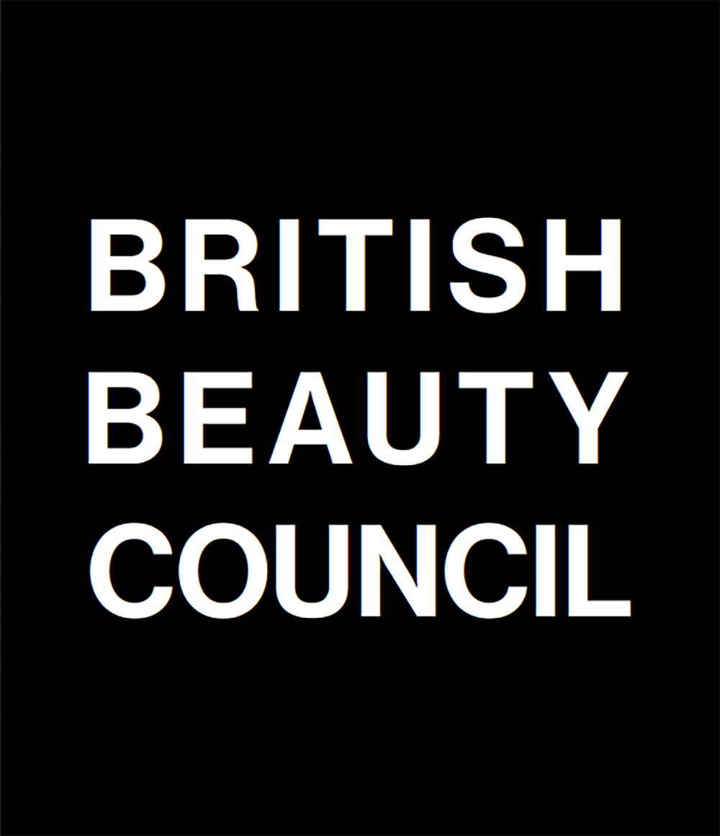
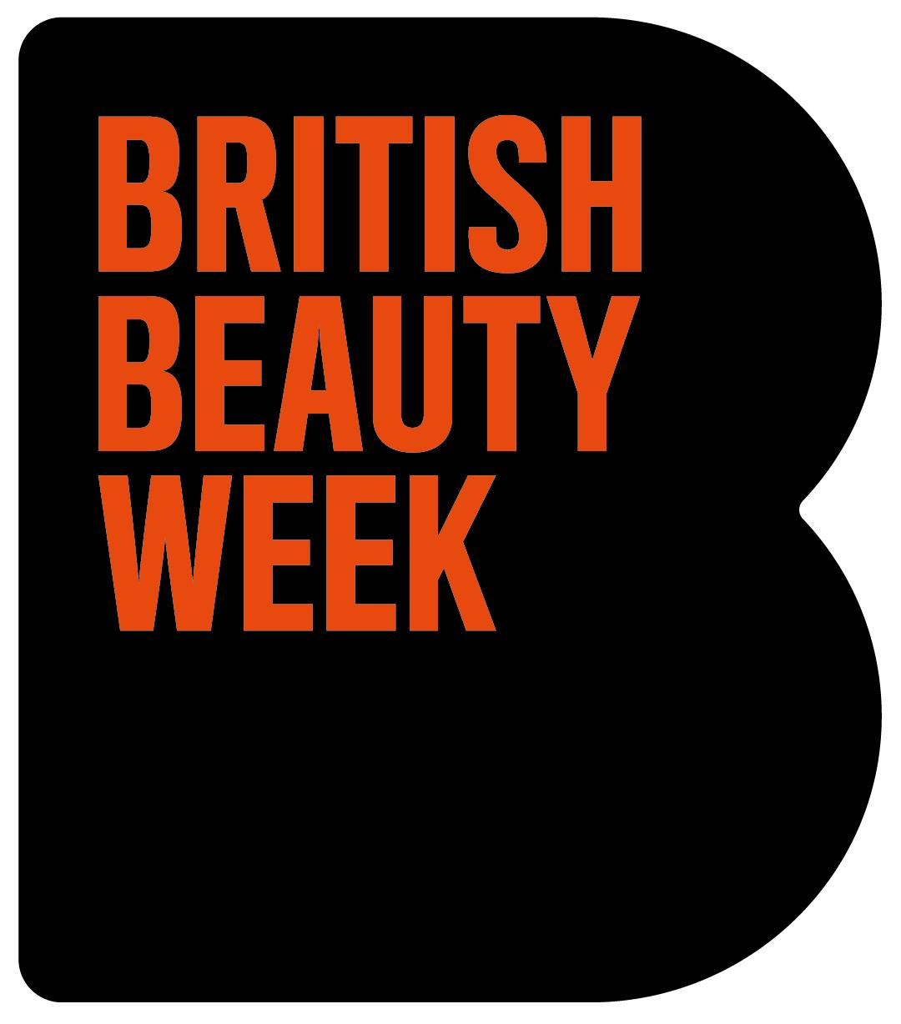
TEMPLATE LETTER FOR BUSINESSES TO SEND TO THEIR LOCAL MP

X MP [FIND YOUR LOCAL MP HERE]
House of Commons
London
SW1A 0AA
07 July 2025
Dear X
Re: Visit your local business during British Beauty Week
I am writing to invite you to visit my business, [insert business name here], in your constituency during the UK’s annual ‘British Beauty Week’ this October.
As part of a nationwide movement during British Beauty Week, MPs from across the UK will be visiting businesses from across hair, barbering, beauty, nails, spa and wellness on Friday 24 October and I would welcome the opportunity to show you, first hand, my business’s contribution to our local highstreet. From employees to apprentices, to helping people to feel like the best version of themselves – businesses like mine continue to have the largest presence of any retail business on the highstreet, as they have done for the last decade.
Here’s why it’s so important:
Beauty and personal care, which includes businesses like mine across hair, barbering, beauty, nails, spa and wellness, contributes £30.4 billion to the UK economy; that’s 1.1% of GDP, 9% growth from 2023-24 and four times faster than the wider economy. It also generates £32.4 billion in consumer spending and has had the largest presence of any retail business on the highstreet for the last decade. Collectively, we employ 697,000 people from all backgrounds, any educational level, and give opportunities to build rewarding and lasting careers.
In terms of my salon/business, [insert some information about your business here – how long you have been operating, people you employ, apprentices or learners you train, individual things that set your business apart form the rest and demonstrate its contribution to your local area].
About British Beauty Week:
Each year, the British Beauty Council hosts British Beauty Week – a celebration of the British beauty industry, its £30.4 billion contribution to the economy, and all that it has to offer from talent, careers, entrepreneurship, innovation, technology, and diversity.
In 2024, British Beauty Week reached more than 52 million people across press, social media and in-person activations, spotlighting the power of the industry and its 697,000 workforce across the UK. This year, it’s set to be even bigger.
Propping up the industry are businesses like mine up and down the country that are the life blood of our highstreets, providing community services, local employment, and helping people feel like the best version of themselves.
What next?
Please let me know if you are able to accept my invitation to visit my [salon/business] on Friday 24 October, to both learn about and shine a light on businesses like mine across the beauty industry. For ease, I can be reached via [insert email] or [insert phone number] to arrange this further.
I look forward to hearing from you.
Yours sincerely
[insert signature]
[insert name]
[insert business name]

